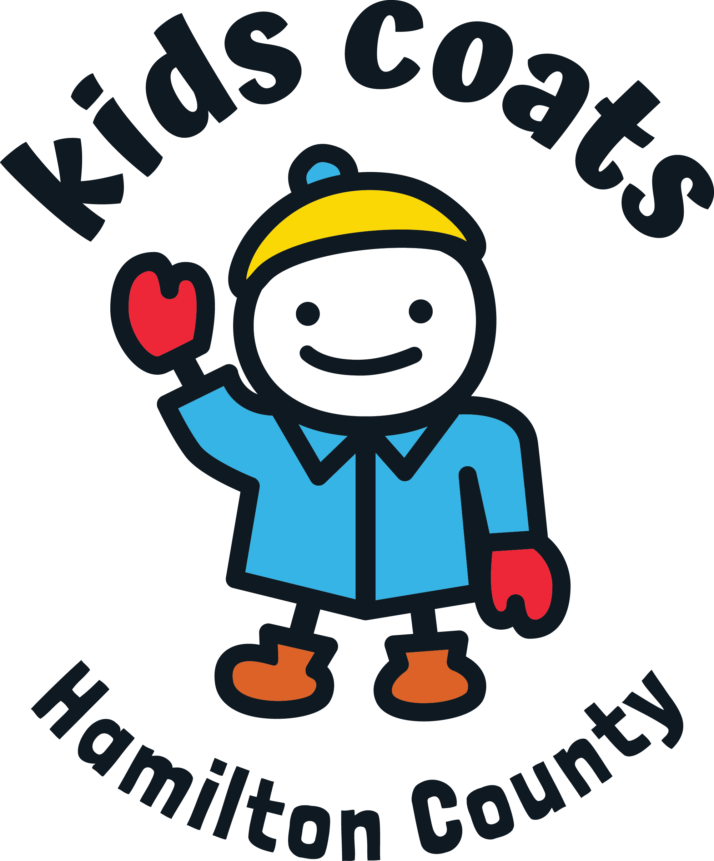Your Organization Making a difference in our community!

We need your clean coats,
mittens, gloves, hats and boots!
All sizes: infants to adults
Place donated items
Location: _______________________________________
Dates of Collection: ____________________________
Thank you for your contribution!

Help keep our Hamilton County families warm this winter!
Donations will be distributed:
October 28 – Arcadia & Westfield
Arcadia Brethren Church 8989 East 266th Street
CrossRoads Church Westfield 19201 Grassy Branch Rd
November 4 – Carmel, Fishers, & Sheridan
Carmel United Methodist Church 621 S. Rangeline Road
St. Louis de Montfort Catholic Church - 11441 Hague Road
Sheridan First United Methodist Church 207 E. 2nd Street
November 18 – Noblesville
Green Valley Church of Christ 19005 Cumberland Road
For more information see:
kidscoats.org
Your Organization
Making a difference in our community!

We need your clean coats,
mittens, gloves, hats and boots!
All sizes: infants to adults
Place donated items
Location: _______________________________________
Dates of Collection: ____________________________
Thank you for your contribution!

Help keep our Hamilton County families warm this winter!
Donations will be distributed:
October 28 – Arcadia & Westfield
Arcadia Brethren Church 8989 East 266th Street
CrossRoads Church Westfield 19201 Grassy Branch Rd
November 4 – Carmel, Fishers, & Sheridan
Carmel United Methodist Church 621 S. Rangeline Road
St. Louis de Montfort Catholic Church - 11441 Hague Road
Sheridan First United Methodist Church 207 E. 2nd Street
November 18 – Noblesville
Green Valley Church of Christ 19005 Cumberland Road
For more information see:
kidscoats.org

